月 日 , 2012
Nassau County Executive Edward P. Mangano
Office of the Nassau County Executive
1550 Franklin Avenue
Mineola, NY 11501

Dear Nassau County Executive Edward P. Mangano:

I think you may be surprised to receive this letter from Japan, but I would greatly appreciate it if you would read it to the end.

I’m writing this letter to let you know how deeply disappointed the people of Japan are with your decision to build the second monument for so-called “comfort women” in the Eisenhower Park in Nassau County.

According to the South Korean media, it usually takes two years to complete the necessary procedures to build such a monument in a public place in your country, but this time the Korean side finished all the procedures in only two weeks and half because they feared interference from the Liberal Democratic Party of Japan. They said everything was done behind closed doors.

It’s very regrettable that you decided to build this monument without giving the Japan side the opportunity to defend itself and provide the documents which clearly show the South Korean misrepresentations concerning this matter.

The US and Japan have been indispensable allies for a long time, and I hope our close relationship will continue in the future, but this problem is starting to erode this relationship here in Japan.

As you perhaps saw in the news about the earthquake-tsunami stricken areas last year, we Japanese are reserved and not so outspoken. We believe that others will understand and believe the truth without us having to explain and complain. But now a lot of Japanese people are learning that if we don’t speak out, the rest of the world will listen to the loud voices, whether they speak truth or not.

There are interesting expressions in Japan and the South Korea which clearly shows the differences between the people of the two countries.

Children who cry the loudest get the most cake. (South Korea)
The last might not always be the least. (Japan).

These saying show that Japanese are taught to be reserved from childhood so that one person’s happiness will not make others unhappy. But perhaps now Japan needs to ignore this aspect of our national character and become bolder in letting the world know what is true and what is not true.
Japan can no longer assume that the world will eventually understand what is true, even though we don’t speak up.

The other day, several South Korean media sources reported that “Japan’s human trafficking problem is serious, and many of the victims are Korean women.” Surely, Japan’s anti-human trafficking measures are weak and insufficient compared to America and European countries.
A US organization has put Japan in the B class concerning human trafficking problems. However, throughout the long history of Japan, the concept of slavery and human trafficking has not existed.

The Korean media reported that the Korean women came to Japan, deceived by the Korean brokers. They believed that they could earn a lot of money easily here in Japan. Moreover, they believed they could attend Japan’s universities. But eventually, they were forced into the sex industry by Korean brokers.
They didn’t ask for help from the Japanese police because they insisted that knew the Japanese police wouldn’t do anything to help them. It’s natural to think that they should have asked for help from the Korean embassy in Japan. The South Korean media blamed all the problems on Japan. The way the media treated this issue revealed their prejudice against Japan, but it is the same pattern seen in the way they treat the so-called “comfort women” during World War II.

As you may know, one of the biggest issues is the so called “comfort women.”
The Korean government repeatedly demands an official apology from the Japanese government and also compensations for “comfort women” who claim themselves to be the victims, having been forced to become “comfort women” by the Japanese troops during World ll.
But this is the issue which was resolved by Japan and the South Korea under the Treaty on Basic Relations between Japan and the Republic of Korea in 1965.
It took more than ten years to conclude the Treaty. During so called the Tokyo Trial and the negotiations for the Treaty, the issue of “comfort women” was never brought for discussion though Rhee Syngman, the first President, who never stopped openly denouncing Japan.

In 1983, a former Japanese soldier suddenly claimed that Japanese soldiers had hunted for Korean women in Cheju to force them into sex service for Japanese soldiers. However, elderly people who were familiar with the situation during that time denied this claim in the Cheju newspaper in 1989. One 85-year old woman at that time said that if 15 women had actually been forcibly taken away from a village with only 250 families, it would have been big news, but, she said, that did not happen. And even the Japanese soldier in question admitted he lied in 1995.

Afterwards, with agitation from Japanese leftist groups, many Korean women suddenly started speaking out, saying, “I was one of the comfort women” to possibly receive a large compensation from the Japanese government in 1991. However, it is very strange that not a single woman came forward for more than 40 years after the war.

The testimonies of these women are very difficult to believe because their “facts” change with each telling. It has been documented that some of these women have changed their stories more than ten times. Their testimonies are not backed by provable facts or documentation.

No cases have been reported of Korean women protesting or escaping while they were being transported.

During the war, there were hundreds of thousand Korean soldiers fighting as Japanese soldiers along with the Japanese soldiers. Why were they silent? Why didn’t they do anything to prevent their women from taken away and forced into sex service?

The Japanese government conducted careful investigations and examination of the related documents and listened to the testimony of witnesses from December 1991 to August 1993.

Based on their careful research, the Japanese government officially denied “enforceability.”

BEHIND THE COMFORT WOMEN CONTROVERSY: HOW LIES BECAME TRUTH
http://www.sdh-fact.com/CL02_1/39_S4.pdf
NISHIOKA Tsutomu
Professor, Tokyo Christian University
Deputy Chairman, National Council for the Rescue of Japanese Abducted by North Korea

It is estimated that there are currently 100,000 Korean women working overseas as prostitutes:
50,000 are in Japan and the rest are in America , Australia and other countries. What does it indicate? It’s quite natural to think a certain number of Korean women will become prostitutes if compensated.

I’m enclosing some data which is posted on the White House petition.
I’d really appreciate it if you could look them through to the end.

Sincerely yours,
署名

なまえ

住所

Japan
< What is the “Comfort Women Issue?” >
The term “comfort women” refers simply to prostitutes in wartime. But Koreans have long been promoting the “Discount Japan campaign”,a false version of history that Japan abducted hundreds of thousands of
Korean women and coerced them into sexual services for Japanese soldiers outside of Japan during World War Ⅱ.
This is, for practical and logical reasons, a fictitious version of history.
The U.S. Miltary official document “Japanese Prisoner of War Interrogation Report No. 49.” exclusively and vividly shows how well comfort women were treated. They were simply not sex slaves.
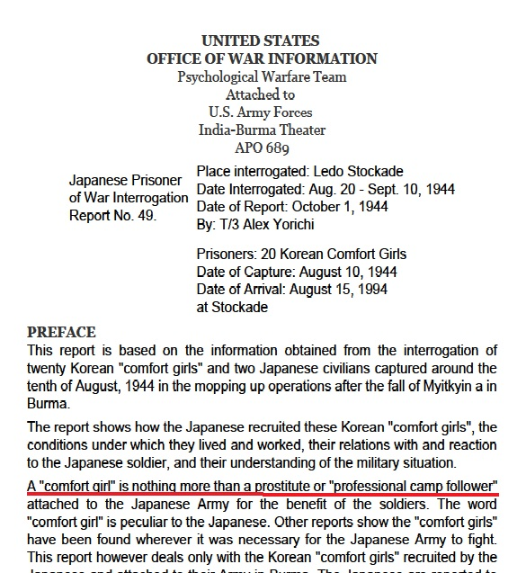
********************************
A Korean comfort woman named Moon Ok-ju, a former prostitute who worked in Burma, visited the Shimonoseki Post Office in Japan to withdraw her savings, and found out her original ledger was discovered and confirmed.(Note: In Japan, the Japanese Post Office has several banking functions.)
She worked in Burma during the period of two years and three months between June 1943 and September 1945, and accumulated a total savings of 26,145 yen in deposits at the military post office. In the 1940s, 5000 yen would have been enough to purchased a house in Tokyo.
A former Korean comfort woman’s deposits:
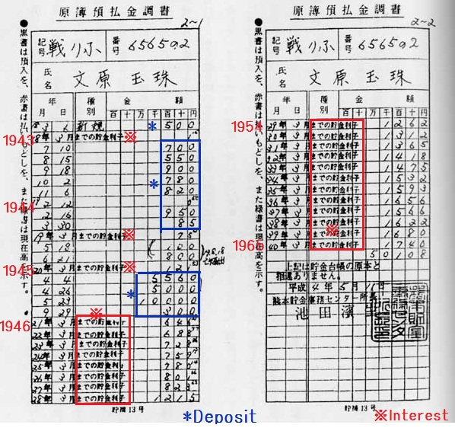
********************************
Newspaper advertisements recruiting comfort women appeared in the Keijo Nippo and Mainichi Shinpo, the large Korean daily papers during that era, stating that remuneration was 300 yen per month, and that advances of up to 3,000 yen might be granted. The monthly pay of a Japanese Army private at the time was 7.5 yen, and a sergeant made 30 yen.
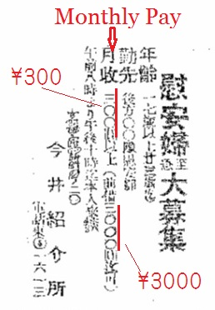
Advertisement in Keijyo Nippo (Seoul Daily, Japanese language newspaper published in Keijo, the colonial capital of Korea,) , 26th July 1944 edition.
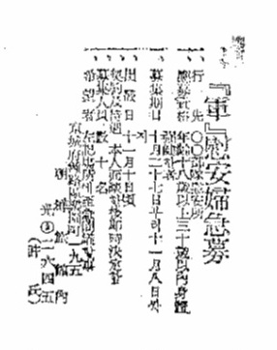
Advertisement in Mainichi Shinpo (Japanese and Korean-language newspaper published in Korea), 27 October 1944 edition
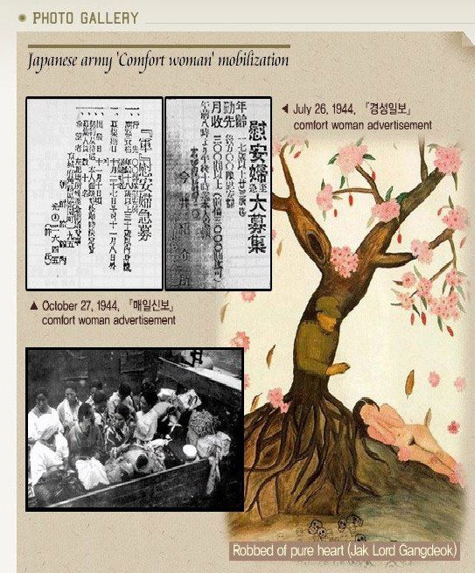
Source material released by the Korean government in an attempt to demonstrate that Korean women were coerced into serving as comfort women; strangely enough, it includes newspaper advertisements for comfort women
********************************
During the annexation of Korea by Japan, all the mayors of the villages in Korea were Korean, and most of the police officers were Korean.
The South Koreans insist that 200,000 women were abducted by the Japanese troops from villages.
To abduct such a huge number of women would not have been easy.
If Japanese troops had abducted the women from the villages, where were all the village mayors and policemen? Why didn’t the Korean people do anything to guard and help the women? Why didn’t they do anything when their people, and especially their women, were taken away by the Japanese troops? Why weren’t there anti-Japan movements?
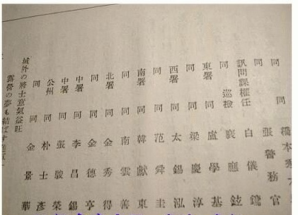
A list of police officers with Korean names
********************************
In 1983, a former Japanese soldier,Seiji Yoshida, suddenly claimed that Japanese soldiers had hunted for Korean women in Cheju to force them into sex service for Japanese soldiers. However, elderly people who were familiar with the situation during that time denied this claim in the Cheju newspaper in 1989. One 85-year old woman at that time said that if 15 women had actually been forcibly taken away from a village with only 250 families, it would have been big news, but, she said, that did not happen. And even the Japanese soldier in question admitted he lied in 1995.
Afterwards, with agitation from Japanese leftist groups, many Korean women suddenly started speaking out, saying, “I was one of the comfort women” to possibly receive a large compensation from the Japanese government in 1991. However, it is very strange that not a single woman came forward for more than 40 years after the war.
The testimonies of these women are vey difficult to believe because their “facts” change with each telling. It has been documented that some of these women have changed their stories more than ten times. Their testimonies are not backed by provable facts or documentation. See the table below.
Differing Versions of Lee Yong-Soo’s Account of Her Kidnapping
Lee Yong-Soo is a former comfort woman who lives in Seoul at Nanum House, a home for former comfort women. She has visited Japan several times to tell her story.
 |  | Date of testimony | Circumstances of kidnapping
1 | Report submitted to Korean Council for Women Drafted for Sexual Slavery by Japan  Akashi Shoten, ed., Shogen: kyosei renko sareta Chosenjin gun ianfutachi (Testimonies of forcibly recruited Korean comfort women) (Tokyo: Akashi Shoten, 1993), pp. 131-143. | 1992 | Delighted to receive a red dress and leather shoes from a man wearing clothing resembling a uniform.  Went along with him right away (otherwise, same as 6).
2 | Women’s International War Crimes Tribunal on Japan’s Military Sexual Slavery | December 2000 | Deceived by Japanese man (comfort station proprietor)
3 | Akahata (Japan Press Weekly, Japanese Communist Party’s paper) article | 26 June 2002 | Kidnapped at bayonet point at the age of 14..
4 | Speech at Kyoto University in Japan | 12 April 2004 | Kidnapped by a man wearing clothing resembling a People’s Army uniform.
5 | Koshigaya (Saitama Prefecture, Japan) community meeting | 08 March 2005 | Kidnapped by a man wearing clothing resembling a military uniform and brandishing a rifle.
6 | Hearing at U.S. House of Representatives | 15 February 2007 | In the autumn of 1944, when I was 16 years old, my friend, Kim Punsun, and I were collecting shellfish at the riverside when we noticed an elderly man and a Japanese man looking down at us form the hillside. The older man pointed at us with his finger, and the Japanese man started to walk towards us. The older man disappeared, and the Japanese beckoned to us to follow him. I was scared and ran away, not caring about what happened to my friend. A few days later, Punsun knocked on my window early in the morning, and whispered to me to follow her quietly. I tip-toed out of the house after her. I lift without telling my mother. I was wearing a dark skirt, a long cotton blouse buttoned up at the front and slippers on my feet. I followed my friend until we met the same man who had tried to approach us on the riverbank. He looked as if he was in his late thirties and he wore a sort of People’s Army uniform with a combat cap. Altogether, there were five girls with him, including myself.
7 | Japan Times article  Testimony given at House of Councillors’ Building on February 21, 2007. | 22 February 2007 | “On an evening in 1944, Japanese soldiers forced their way into 14-year-old Lee’s home and dragged her out by the neck.”
8 | FCCJ (Foreign Correspondents’ Club of Japan)  Lee’s testimony and a taped question-and-answer session | 02 March 2007 | A soldier and a woman entered her house between 2:00 and 3:00 a.m. on a bright moonlit night. [The soldier] pointed a sword at her, covered her mouth and removed her from her house. The three later met up with another soldier accompanied by three women; Lee was then put on a train.
9 | New York Times article  Based on testimony given by Lee at the U.S. House of Representatives on February 15, 2007. | 06 March 2007 | “Japanese soldiers had dragged her from her home, covering her mouth so she could not call to her mother.”
Reference:
Hata Ikuhiko, Maborosino”Jyugun-ianfu” wo netuzousita Kounodanwa ha kounaose! (Tokyo: Shokun, May 2007);
English title: No organized or forced recruitment misconceptions about comfort women and the Japanese military.
http://www.sdh-fact.com/CL02_1/31_S4.pdf page10
********************************
The Japanese government conducted careful investigations and examination of the related documents and listened to the testimony of witnesses from December 1991 to August 1993.
Based on their careful research, the Japanese government officially denied “enforceability.”
********************************
The Korean police, then under Japanese control, was ordered to arrest procurers who coerced women into serving as comfort women.
The article below concludes by saying that when the police arrested the procurers, there would be full disclosure of the methods used by malicious brokers; for instance, cajoling women into becoming prostitutes by promising extraordinarily high wages.
As the article clearly demonstrates, the Japanese government dealt severely with inhumane crimes against women, and the military neither kidnapped nor abducted women.
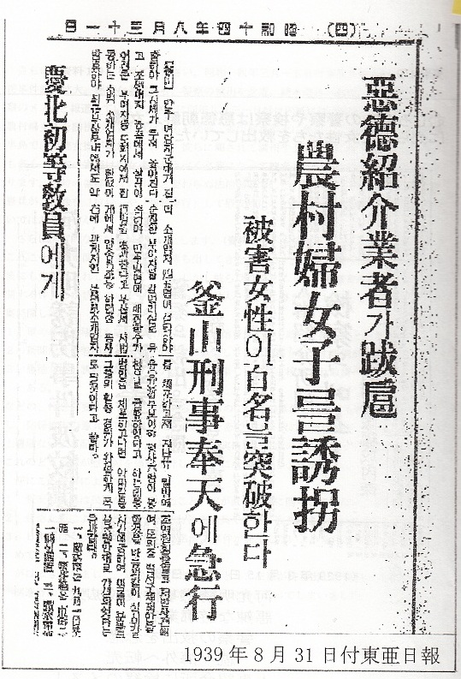
the August 31, 1939 edition of the Korean newspaper Toa Nippo (East Asian Newspaper)
********************************
And what were American GIs doing in Korea?
Articles appearing in Dong-a Ilbo, one of Korea’s leading dailies, on January 31 and September 14, 1961 answer the question.
The January 31 article describes a training course for 800 prostitutes conducted by US Army officers and Korean police. Taking strict precautions to prevent the spread of venereal disease was the main focus of the program.
The September 14 article states that the police in Seoul had asked municipal authorities to oversee the registration of prostitutes who serviced United Nations Command soldiers, again in an attempt to prevent the spread of venereal disease.
Therefore, we know that American military personnel procured prostitutes locally, with the cooperation of the Korean government.
The brothels for the military were not particularly unusual. Every country in the world had them.
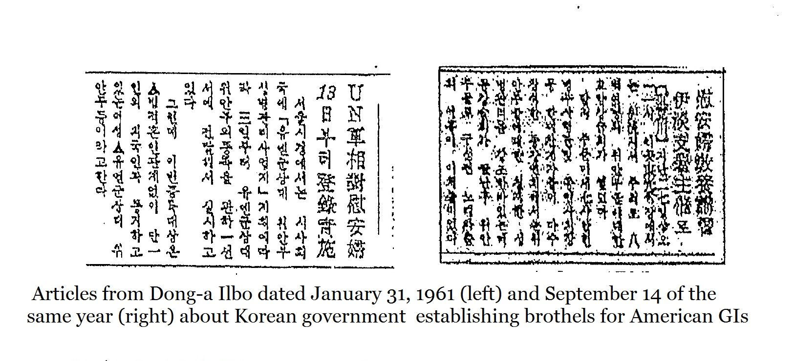
********************************
Japanese military sexual slavery is completely at odds with historical truth. Wide-spread misconceptions are a violation of our country`s dignity and honor. This could negatively affect our relationship with all nations. Japanese are distressed by this situation, and wish to resolve global misinterpretations and misinformation about the comfort women.

