月 日 , 2014

Lord Mayor Clover Moore
City of Sydney
GPO Box 1591
Sydney, NSW 2001
Australia

Dear Lord Mayor Clover Moore:

I hope this mail finds you in excellent health.

Recently, I knew in an article that Chinese and Korean communities in Australia set up an Anti- Japanese war crimes Alliance, and they are planning to erect a statue of "comfort women" in Sydney.
Also I read another article titled “Australian wartime sex slave, Jan Ruff-O'Hearne hits out at 'hideous Japanese denials” February 25, 2014. [Attachment 1]

First of all, I must remind you that the word "comfort women" simply signifies “prostitutes at the war”. Japanese traditional periphrastic way of expression replaced the word “prostitutes at the war” with a gentle appellation “comfort women”, respecting the human rights of prostitutes.

I deeply have compassion for hard lots of comfort women (prostitutes at the war). But I strongly protest the assertion of this article. Because it’s a completely misunderstanding that comfort women (prostitutes at the war) were sex slaves and that the comfort women system (prostitutes at the war system) was a crime committed by Japanese army.

The brothel in Semarang in Indonesia where Mrs. Ruff-O'Herne testified to have been was closed quickly by Japanese higher officer as soon as default of military discipline was discovered. This proves that Japanese Army strictly prohibited the forcible prostitution. Furthermore responsible officers of Japanese Army were sentenced to death in 1948 at the Military Tribunal in Netherlands. So the case is quite rare. And this crime has nothing with comfort women system (prostitution at the war system).

In the first place, there is a big difference on the status between Mrs. Ruff-O'Herne and Korean comfort women (Korean prostitutes at the war). Mrs. Ruff-O'Herne was interned as a citizen of enemy country. On the other hand Koreans were neither enemy nor prisoners. Quite contrary, they had Japanese citizen status. Korea at that time was a part of Japan (Korea was not Japanese colony but annexed to Japan). Koreans had the same equal rights as a Japanese citizen.

Please read Japanese Prisoner of War Interrogation Report No.49 in 1944 by US Army where Korean comfort women were reported as simple prostitutes, not as sex slaves (it’s quite indisputable) [Attachment2]

A comfort women statue proposed by Korean-Americans was installed last July in a public park in Glendale City, Ca, USA. Great number of Japanese people feel very strong resentment against this situation. As a result, Glendale City becomes most disgusted city among Japanese. Now Japanese in California started a suit for removal of the statue.

This is a very complicated issue at the international level at which local city of Sydney in Australia has nothing concerned. If the same one would be installed, Sydney would have the same destiny of Glendale city, that is, a disliked city among Japanese. I really wish this doesn’t happen.

I hope City of Sydney will make a realistic decision not to be involved in this issue when Chinese and Korean communities make an application for installation of comfort women statue, that is, a statue of prostitutes at the war.

Sincerely yours,
署名

なまえローマ字で

住所

Japan

[Attachment 1]
The Sydney Morning Herald February 25, 2014
http://www.smh.com.au/national/australian-wartime-sex-slave-jan-ruffohearne-hits-out-at-hideous-japanese-denials-20140224-33d4o.html
-------------------------------------------------------------------------------------------------------------------------------- Australian wartime sex slave Jan Ruff-O'Hearne hits out at 'hideous' Japanese denials

When she was a 21-year-old young woman, Japanese soldiers raped and beat Jan Ruff-O'Herne so many times she lost count.
Along with thousands of other women across Asia she was forced to be a sex slave of the imperial army during World War II.
Now the conservative Japanese government has questioned the testimony of the ''comfort women'' that led to the landmark apology won from Tokyo in 1993.
The move has placed a further pall over Japan's already tense relationship with China as well as South Korea, countries the Japanese occupied and home to most of the estimated 200,000 sex slaves.
'It's just hideous to not acknowledge it, there are so many witnesses who have spoken out about this,'' Mrs Ruff-O'Herne said from her home in Adelaide.
Supporters of the abused women fear an attempt to airbrush history after Japan's chief cabinet secretary Yoshihide Suga last week indicated the government wanted to verify the authenticity of testimony from 16 South Korean women recorded in the lead-up to the 1993 apology.
Jan Ruff-O'Herne at about 17 years of age just before she was captured by the Japanese.
No inquiry has been launched but ultra-conservatives in Japan's parliament dismiss the stories and say there are no documents to prove Japanese soldiers forced women into sexual servitude.
But Mrs Ruff-O'Herne, now 91, said Japanese leaders must come to terms with the country's history of war crimes. She was captured as a teenager with her Dutch parents on Java, Indonesia, and later forced into a brothel. She migrated to Australia in the 1960s.
For 50 years, she kept secret her abuse at the hands of Japanese soldiers, even from her family until speaking out in the early 1990s in support of Korean women seeking an apology from Japan.
''First it was only the Korean women, and nobody took any notice because 'they were only Asian women'. But then when a European woman spoke out the world suddenly took notice,'' Mrs Ruff-O'Herne said.
The pressure led to the Japanese government issuing a remarkable statement of ''apologies and remorse'' for abused women, with a promise to teach people about what had taken place.
Tessa Morris-Suzuki, an expert on modern Japanese history at the Australian National University, said the ''comfort women'' had become symbolic in the revisionist drive trying to argue Japan was as much a victim as the aggressor.
''From the point of view of people like Mr Abe and others in his government, it is something that makes Japan look very bad … they want to say this didn't happen, or it didn't happen the way people think it did - or if it did happen, everybody else did it as well,'' she said.
A spokesman for the Japanese embassy said his government stood by past statements yet believed in more discussions from ''an academic stand point'' on issues surrounding comfort women.
Mrs Ruff-O'Herne said the apology must stand. ''When such a terrible thing happens, you expect an apology. It was important for my healing process. It takes a lifetime to get over a thing like that.''

[Attachment 2]
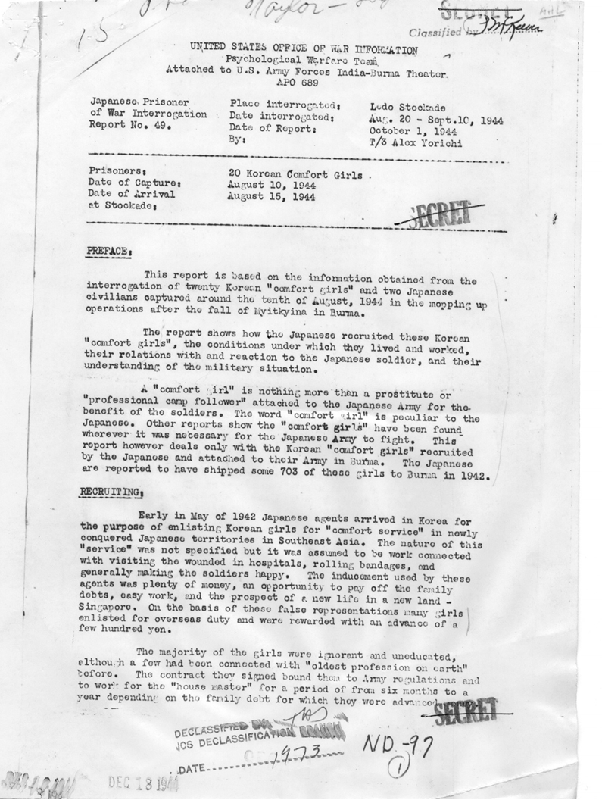
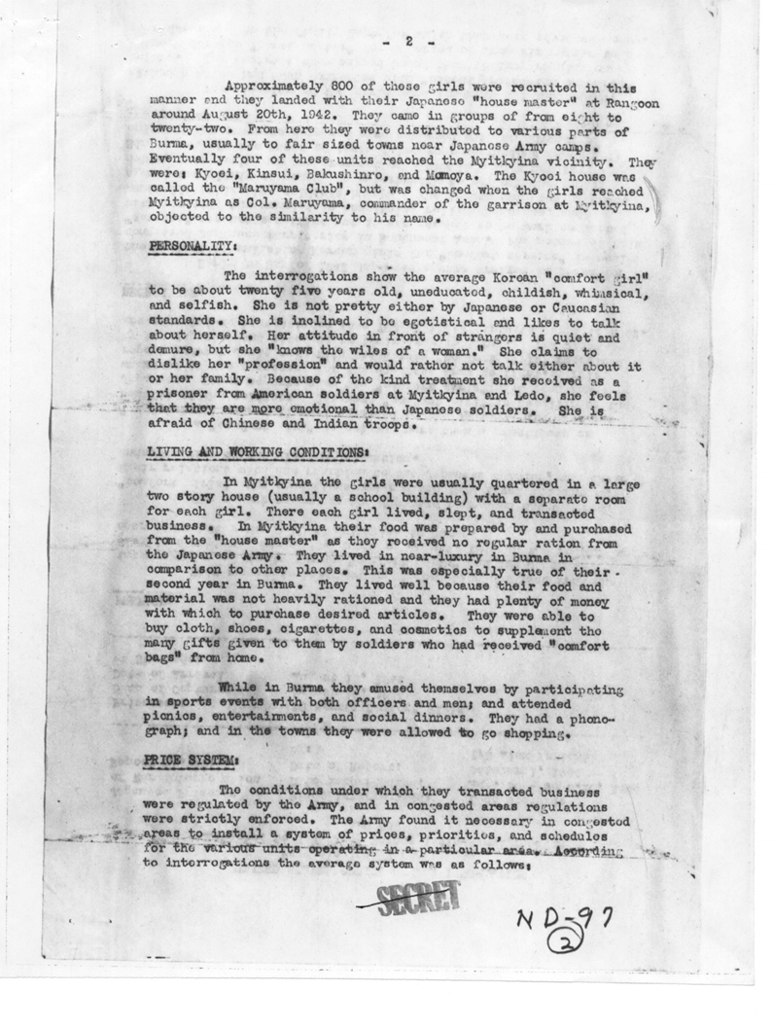
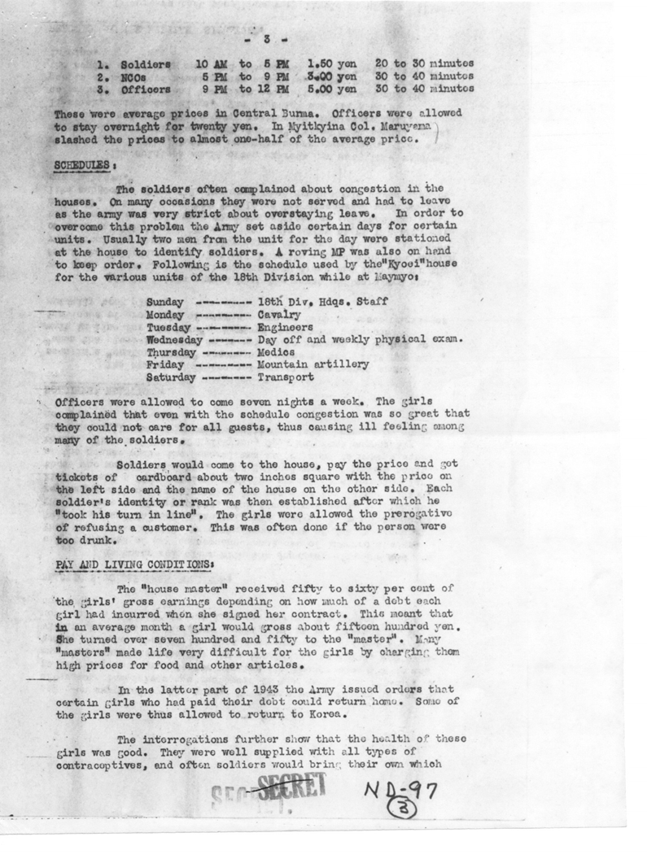
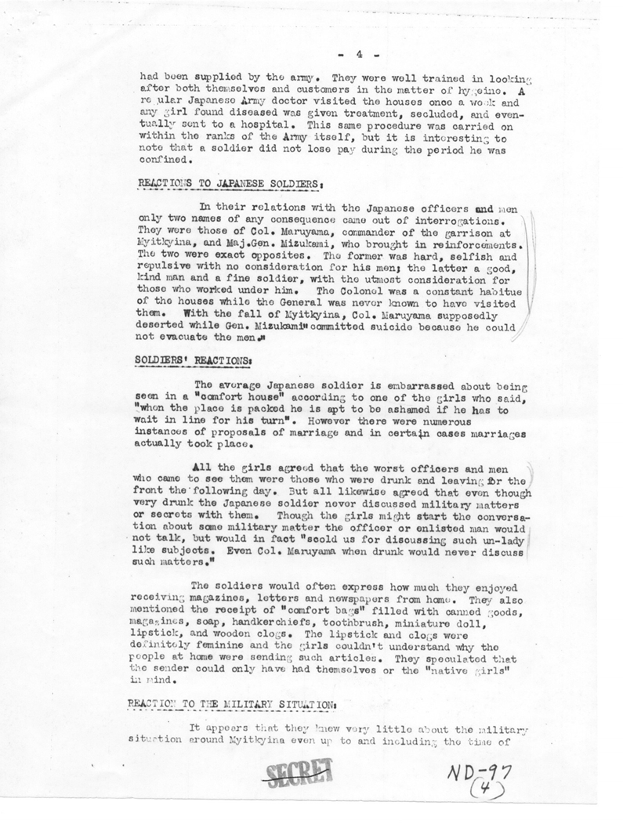
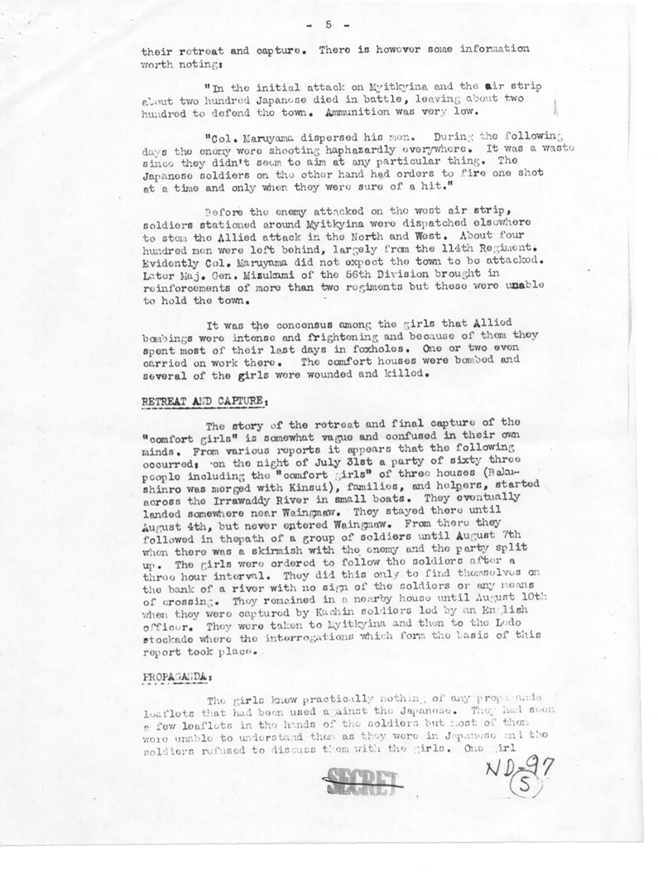
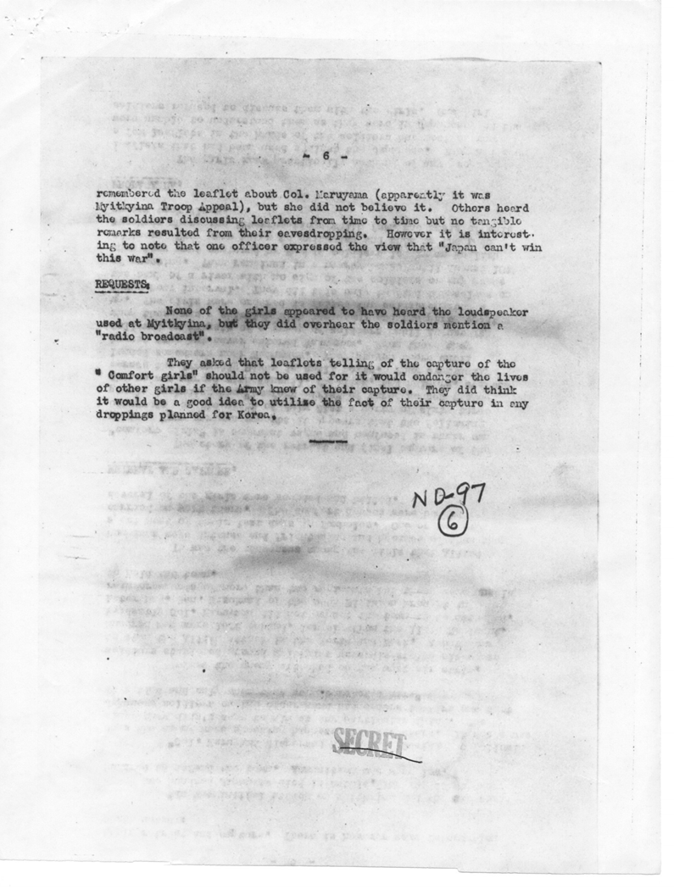
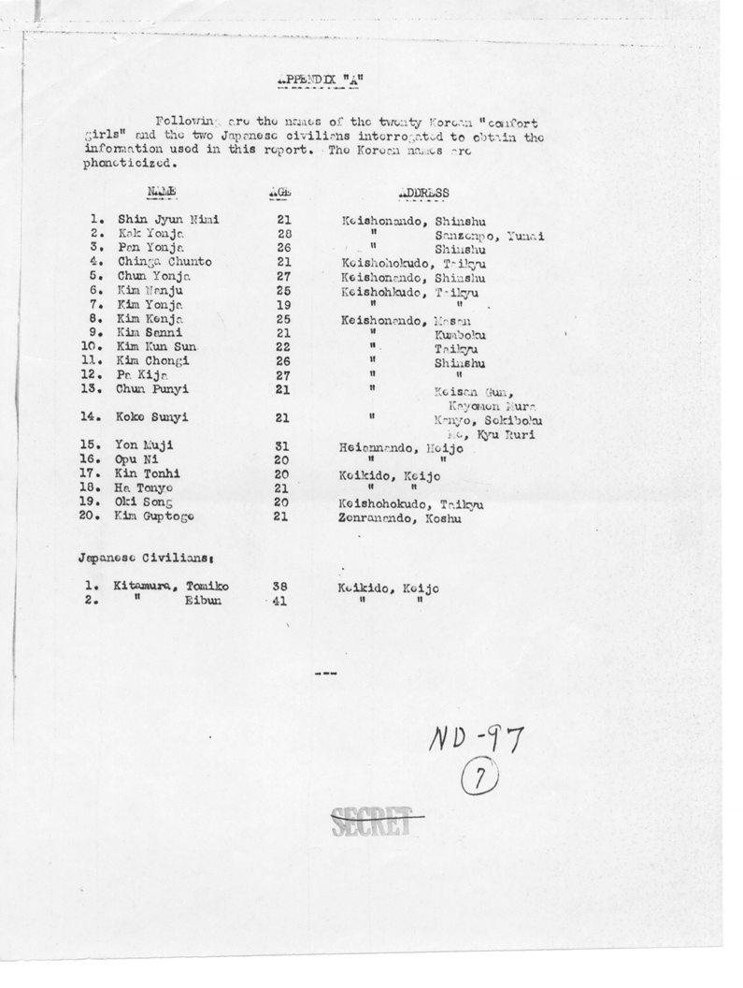

＜手紙の日本語訳＞ ※このページは郵送用ではありません

クローバー・ムーア シドニー市長

ご健勝のことと思います。

最近、オーストラリアに在住の中国人と韓国人とが「日本の戦争犯罪糾弾同盟」なるものを立ち上げ、シドニーに慰安婦像を設置する計画がある」ということを、記事で知りました。又 「戦時性奴隷だったオーストラリアのオヘルネさんが、日本のおぞましい戦時犯罪否定を攻撃」という２０１４年２月２５日付けの別の記事も読みました。[添付１]

まずお断りしておきたのは、「慰安婦」という言葉は単に戦時売春婦を指すものです。「慰安婦」という呼称は、売春婦の人権を慮って、日本の伝統的婉曲表現によりやさしい言葉に変えたものです。そこをしっかりご理解ください。

慰安婦（戦時売春婦）の方々が大変苦労されたことに同情を持っています。しかしこの記事に対しては強く抗議します。なぜなら慰安婦（戦時売春婦）が性奴隷であり、慰安婦制度（戦時売春婦制度）が日本軍によって行われた犯罪制度であるという主張は全くの誤解であるからです。

オヘルネさんがいたと言うインドネシアのスマランのオランダ女性の慰安所は日本軍上司が発見した直後に閉鎖されました。これは日本軍が強制売春を取り締まっていたことを証明します。この事件は１９４８年オランダ軍事裁判でとりあげられ、日本軍の被告は死刑になっています。この事件は特別なケースであり、慰安婦制度（戦時売春婦制度）とはなんの関係もありません。

そもそもオヘルネさんの置かれた立場と韓国人慰安婦（戦時晩春婦）との立場には大きな違いがあります。
オヘルネさんは敵国人として収容されていた方です。一方、韓国人慰安婦は敵国人でも捕虜でもありません。そればかりか、彼女たちは日本人としての地位を持っていた人達です。当時の韓国は日本の一部であり（日本の植民地ではなく、日本への併合です）、韓国人は日本人として、同等の市民権を保持していました。
どうか１９４４年の米軍の報告書をお読みください。
[添付UNITED STATES OFFICE OF WAR INFORMATION ]
そこには、韓国人慰安婦は単なる売春婦であると報告されています。性奴隷であるなどと報告書にはありません。（当前のことですが）

米国カルフォルニアのグレンデールで昨年の7月、慰安婦像が在米韓国人の提案により公立公園に設置されました。日本人はこれに対して非常に怒っており、グレンデールは日本人から最も嫌われる街になってしまいました。カルフォルニアの日本人は像撤去の訴訟を始めました。

この件は複雑で国際レベルの問題です。オーストラリアのシドニーという一都市が関わる問題ではありません。もし慰安婦像が建ったら、グレンデールと同じように、シドニーは日本人が嫌う街になってしまうでしょう。その様なことが起こらないことを願います。

中韓のコミュニティーが慰安婦像設置を申請した場合、この問題にかかわることは賢明でないとシドニー市が判断をすることを望みます。

署名

以上

